Changes in Energy and Heat
The First Law of Thermodynamics
All changes in matter involve changes in the energy content of the matter. Such changes in energy are described in terms of systems and their surroundings. Any sample under observation is referred to as a system; the surroundings consist of everything else in the universe. There are three types of systems.
- An open system can exchange both energy and matter with the surroundings.
- A closed system can exchange only energy with the surrounding.
- And isolated system cannot exchange either energy or matter with the surroundings.
When a system releases energy, the surroundings absorb it. Similarly, when a system absorbs energy, the surroundings release it. Energy is neither created nor destroyed when transfers and transformations of energy occur, because the total energy of the universe is constant. This is known as the first law of thermodynamics.
∆E_{system} =-∆E_{surroundings}
Use Q=mc∆T
Enthalpy
Given a system, that system will have a certain amount of energy due to a combination of kinetic energy and potential energy the molecules in that system possess. This energy is referred to as the enthalpy of the system. Another common definition of enthalpy is “a measure of the heat content of a system”.
The absolute value of enthalpy of a given system is not half so much as interesting as when the enthalpy of a system changes. The enthalpy of a system will change when the total energy of the system changes. This can occur when a system undergoes a physical change, a chemical change or a nuclear change.
If the enthalpy of a system decreases (i.e. its heat content decreases or energy leaves the system) then heat will flow into the surroundings. This will be perceived as an increase in temperature. Thus, a decrease in enthalpy is an exothermic change.
If the enthalpy of a system increases (i.e. its heat content increases or energy enters the system) then heat will flow from the surroundings into the system. This will be perceived as a decrease in temperature. Thus, an increase in enthalpy is an endothermic change.

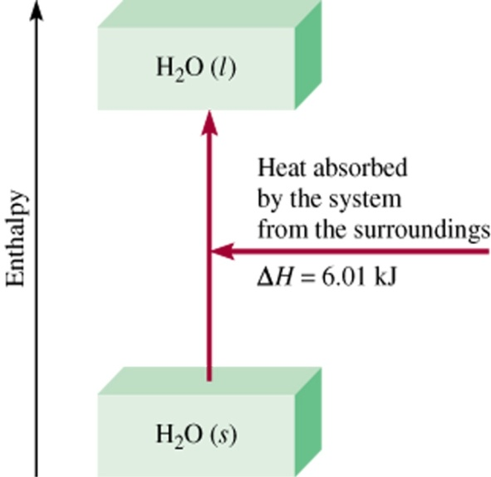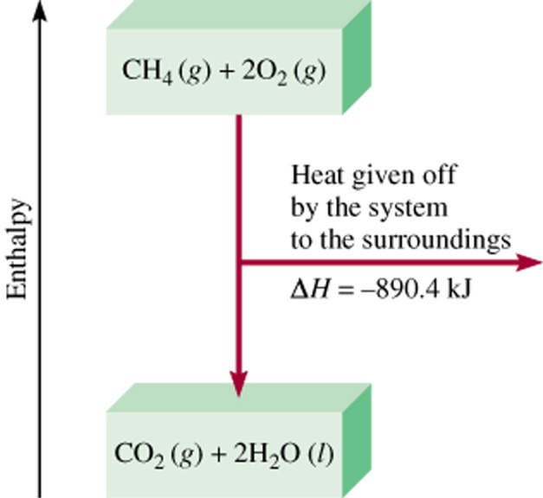

Exothermic change
Endothermic change

Enthalpy and the Second Law of Thermodynamics
To express thermochemical changes in a process, chemists use enthalpy, H, a variable that is not affected by the conditions under which the process occurs. Enthalpy is also called the heat constant of the system, is the total energy of the system plus the pressure times the volume. The enthalpy change of a system depends only on the system’s initial and final states.
A positive enthalpy is referred to as endothermic, and a negative enthalpy is referred to as exothermic. If two systems or objects are in thermal contact, the second law of thermodynamics applies. This law states that heat will be transferred from the object at the higher temperature to the object at a lower temperature (via collisions) until the temperatures of the two objects reach thermal equilibrium.
The categories of enthalpy changes are physical, chemical and nuclear. Two physical changes in systems that are associated with easily studied changes in enthalpy are 1) the dissolving of one substance into another, and 2) phase changes. Larger enthalpy changes occur when chemical reactions take place. Nuclear changes involve the greatest enthalpy changes.

