Log into your explore learning account through D2L

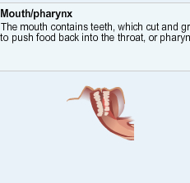

Gizmo Warm-up
The digestive system is a group of organs that does three things:
- First, the digestive system breaks food down into useful nutrients, a process called digestion.
- Next, the nutrients move into the bloodstream, a process called absorption.
- Finally, the leftover waste is removed from the body, a process called elimination.

With the Digestive System Gizmo™, you can arrange the organs of the digestive system any way you like. To begin, look at the organs on the Large Organs tab. Place your cursor over each organ to learn more about it.

- Which organs allow nutrients to be absorbed? ____________________________________

- Which organ stores and compacts waste before it is eliminated? ______________________

- Which two organs help to break food down mechanically? _____________ _____________

\\Activity A:  Build a digestive system | Get the Gizmo ready:  - If necessary, click Clear screen. | 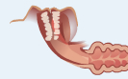

Goal: Design your own digestive system.

- Explore: Read the descriptions of the large organs, as well as those of the Small Organs on the next tab. Fill in the names of the organs that serve the functions listed below:

__________________ This organ absorbs water and vitamin K from digested food.

__________________ This organ produces enzymes that break down nutrients.

__________________ These tiny blood vessels transport absorbed nutrients.

__________________ These cells produce hydrochloric acid (HCl).

__________________ These cells produce pepsin, which breaks down proteins.

- Build: Now it is time to design and build your own digestive system! Start with the Large Organs tab to build a basic system, starting with the Mouth/pharynx. Next, attach organs from the Small organs tab to the large organs to complete your system.

- Prepare: Select the Food tab. The energy we get from food is measured in food calories (Calories). Each Calorie is equal to 4,184 joules of energy. Calories are found in the three main nutrients in food: carbohydrates (sugars and starches), proteins, and fats.

Drag the Cheeseburger above the mouth in your digestive system. How many Calories in the cheeseburger come from carbohydrates, proteins, and fats?

Carbohydrate Calories: ________ Protein Calories: ________ Fat Calories: ________

- Run the Gizmo: Click Play (), and observe the food moving through the digestive system. The muscular contractions that push food through the system are called peristalsis. When food has finished passing through the system, you will see a message.

- What percentage of Calories were absorbed by your system? ________

- What percentage of water was absorbed? ________

- Based on these results, how well do you think this digestive system worked? Explain.

___________________________________________________________________

___________________________________________________________________

___________________________________________________________________

- Revise: Click Reset (). Rearrange the organs of your system to try to improve your results. Describe how you changed your system below.

_________________________________________________________________________

_________________________________________________________________________

_________________________________________________________________________

- Test: Click Play. List the results below. Did the system improve? _____________________

Percentage of Calories absorbed: ________ Percentage of water absorbed: ________

- Explain: If your system improved, why do you think this was so? ______________________

_________________________________________________________________________

_________________________________________________________________________

Activity B:  Absorption | Get the Gizmo ready:  - Click Reset and Clear screen. | 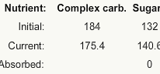

Introduction: Digesting nutrients into simple carbohydrates, amino acids, and fatty acids is important, but it doesn’t matter unless the nutrients get into the bloodstream to feed body cells. This process is called absorption.

Question: How are nutrients absorbed?

- Observe: Look through the descriptions of the large and small organs.

- Which of the large organs allow nutrients and water to pass through their walls?

___________________________________________________________________

- Which of the small organs transport absorbed nutrients to the bloodstream?

___________________________________________________________________

- Set up the Gizmo: Create the digestive system shown. The small intestine has three parts: the duodenum (attached to the stomach), the jejunum (the middle portion), and the ilium (attached to the large intestine). Drag the Pecan pie to the mouth.

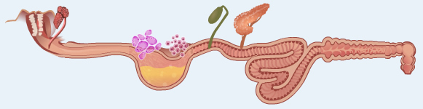

Test each of the scenarios below. For each setup, record the nutrients that are absorbed by the system. (Be sure to look at the “Absorbed” row of the Analysis table.)

Scenario | Sugars | Amino acids  (from protein) | Fatty acids (from fats) | Water
Capillaries attached to the small intestine segments only
Capillaries attached to the large intestine only
Lymphatic vessels attached to the small intestine segments only (no capillaries)
Lymphatic vessels attached to the large intestine only (no capillaries)
- Analyze: Examine the results of your four experiments.

- Which nutrients were absorbed by capillaries in the small intestine? _____________

___________________________________________________________________

- Which nutrients were absorbed by capillaries in the large intestine? _____________

___________________________________________________________________

Bacteria in the large intestine break down some types of fiber—a difficult to digest complex carbohydrate—into sugars and other nutrients.

- Which nutrient was absorbed by small intestine lymphatic vessels? ______________

- Did lymphatic vessels absorb anything from the large intestine? ________________

- Draw conclusions: Based on your experiments, where should the capillaries and lymphatic vessels be placed to maximize the absorption of nutrients from food?

Capillaries: ________________________________________________________________

Lymphatic vessels: _________________________________________________________

- Investigate: Click Reset. From the Food tab, drag the Apple to the work area to view its Nutritional Facts. What nutrient makes up most of an apple’s Calories? _______________
- Explore: Use the Gizmo to determine how absorption of water affects the texture of the stool (poop) that is produced by the digestive system. What do you conclude?

_________________________________________________________________________

_________________________________________________________________________

Optional Challenge: Using a total of only five large organs, design a digestive system that can absorb the maximum number of Calories from the apple. Describe your system below.

_________________________________________________________________________

_________________________________________________________________________

Test: Click Play. What percentage of Calories did your system absorb? _______

